AWS (Cost optimization)
- Cost optimization means reducing unnecessary costs while still getting the same (or better) performance and reliability.
- In easy words:
Use only what you need, pay only for what you use.
- Without cost optimization:
10 servers running 24/7 → High bill
- With cost optimization:
5 servers + auto scaling → Same performance, lower cost
- How to change instance type:
- Stop the EC2 instance → Go to Actions → Change Instance Type → Select a smaller instance → Restart instance.
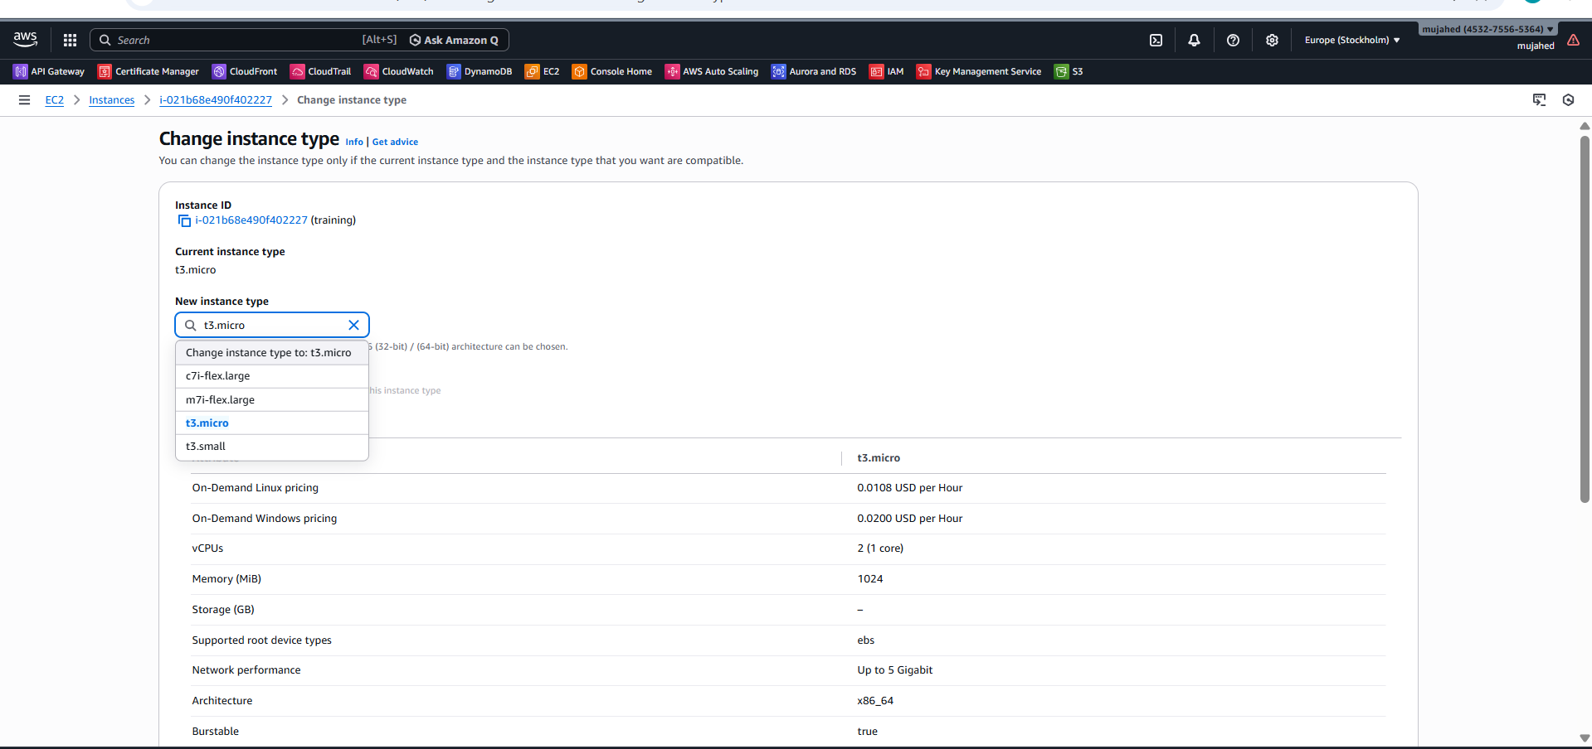

- After selecting the new (smaller) instance type, saving the changes and restarting the instance applies the right-sizing, which directly optimizes the cost of the EC2 instance

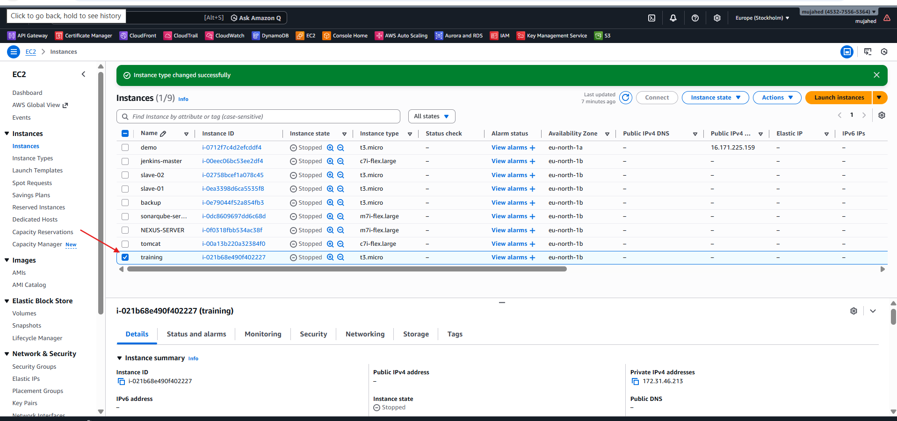
Result:
Same application works
Less cost
Better resource utilization
Right-sizing EC2 is choosing the appropriate instance size to avoid paying for unused CPU and memory resources
- Stop unused instance
Stopping unused EC2 instances, especially dev and test servers, eliminates compute charges and reduces unnecessary AWS costs.
- Stopping Unused EC2 Instances – Simple Explanation
Development and testing servers don’t need to run all the time. When work is finished or applications are not in use, stopping the EC2 instance is a smart way to save money.
A stopped instance does not incur compute charges — only the storage (EBS) cost remains. You can start the instance again anytime when needed.
This method is very effective for dev environments, test setups, and temporary projects, helping avoid paying for idle servers.
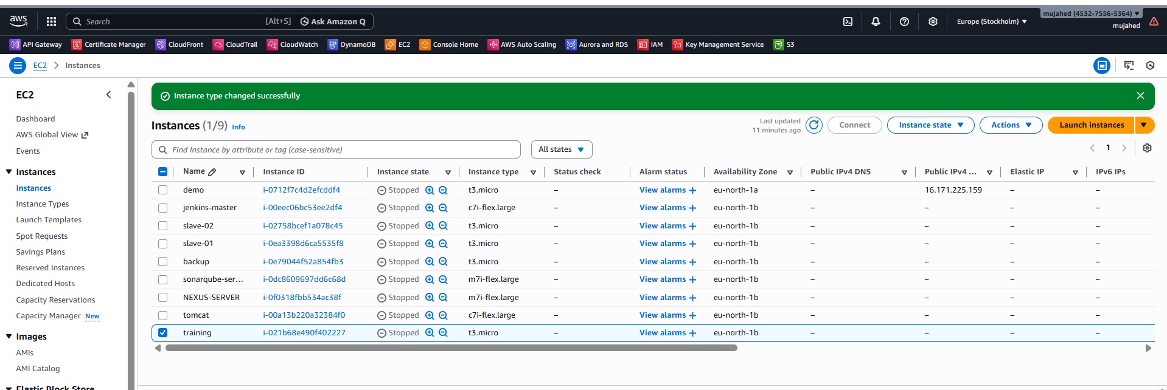
- Use Spot Instances:
Spot Instances provide EC2 capacity at very low prices (up to 90% cheaper). They are best suited for testing, batch processing, and non-critical workloads where interruptions are acceptable.
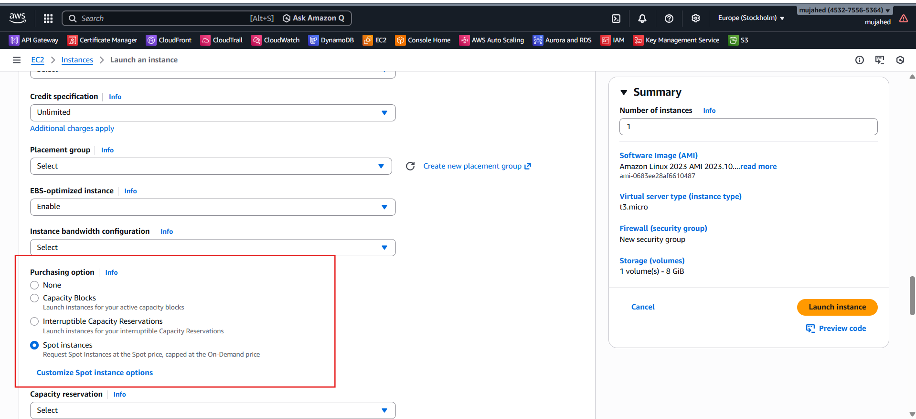
- EBS & Snapshot Cost Optimization
- Unused EBS volumes still incur storage charges
- EBS volumes may remain detached after EC2 termination
- Detached volumes continue to cost money
- If data is not required, delete unused EBS volumes
- Deleting unused volumes reduces storage costs
- Helps avoid unnecessary monthly AWS bills
- Part of AWS cost optimization best practices

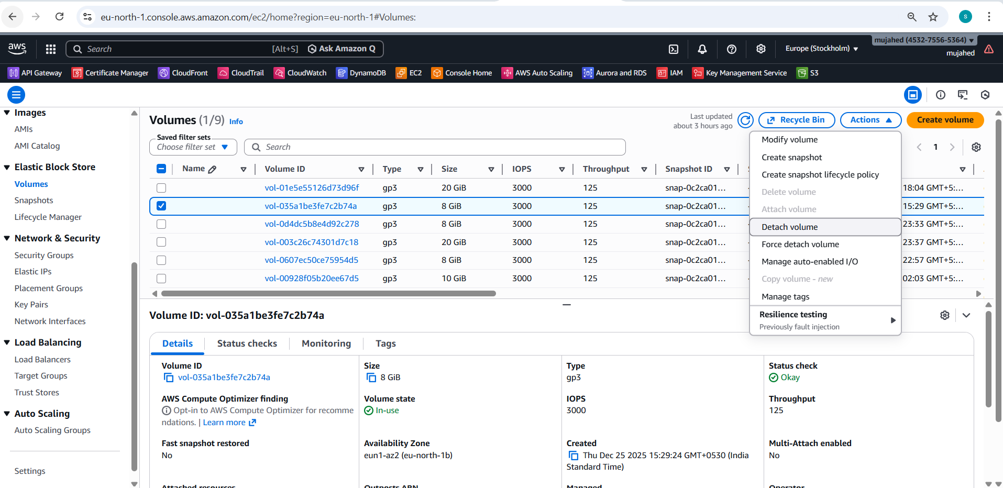
- An EC2 instance is terminated, but its EBS volume remains detached. Since the data is not needed, deleting the unused volume removes storage and saves EBS costs.

- Remove Old Snapshots
- Take daily snapshots
- Keep only last 30 days
- Automatically delete older snapshots
- Reduces storage cost without manual effort
- Deleting or automating cleanup of old EBS snapshots reduces S3 storage costs and keeps backups organized.
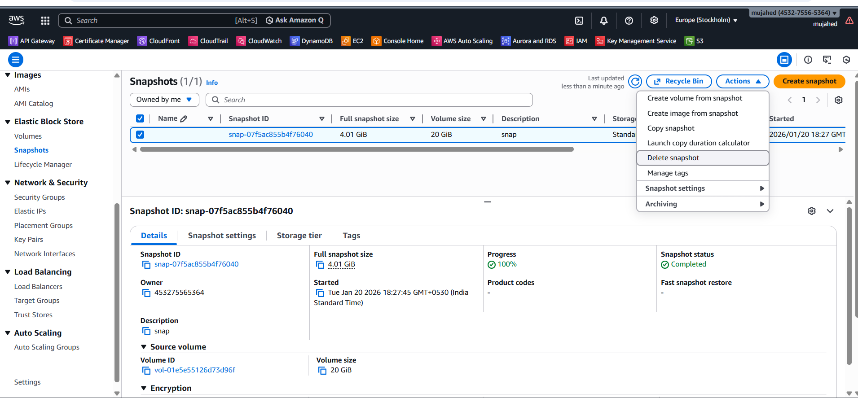
- Identify EBS snapshots that are older than the required retention period (30 or 60 days)
- Verify snapshots are not needed for backup, recovery, or compliance
- Check that related EC2 instances or EBS volumes are terminated
- Select and delete unnecessary snapshots from old projects
- Keep only the latest required snapshots
Configure EBS Lifecycle Manager to:
- Take regular snapshots
- Automatically delete outdated snapshots
- Retain only recent backups
- Monitor reduced storage costs using AWS Cost Explorer

- Choosing the correct EBS volume type helps reduce storage
- cost without affecting performance.
- gp2 and gp3 are General Purpose SSD EBS volume types
- gp3 is more cost-effective than gp2
- gp3 has lower cost per GB
- In gp2, performance is linked to volume size
- To get more performance in gp2, you must increase storage
- In gp3, performance and storage are independent
- gp3 allows required performance without increasing volume size
- gp3 delivers same or better performance at lower cost
Best suited for:
- Web servers
- Application servers
- Dev/Test environments
- Example (Cost Optimization Point)
- 100 GB gp2 → Higher cost
- 100 GB gp3 → Similar performance, lower cost
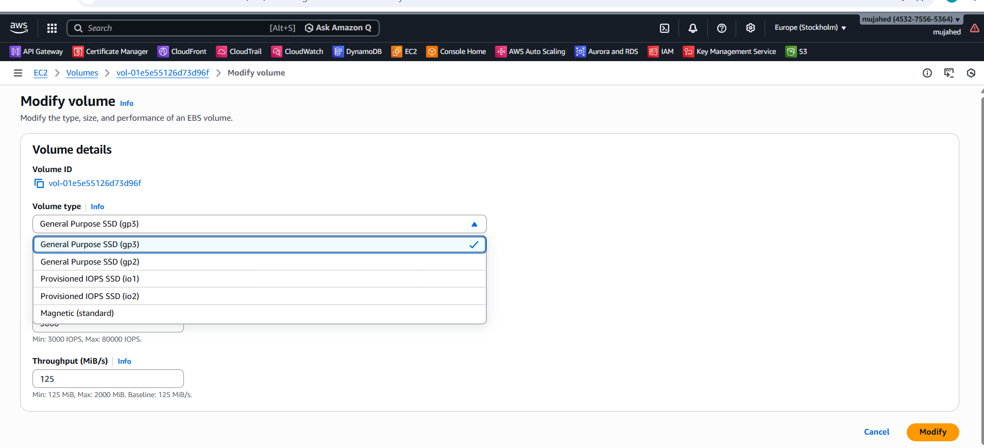
- gp3 is cheaper than gp2 and reduces EBS storage costs
- gp3 provides flexible performance without increasing volume size
- No application impact when migrating from gp2 to gp3
- Migration helps lower monthly EBS charges
- Best practice: use gp3 as the default EBS volume type
- Convert existing gp2 volumes to gp3 for cost optimization

- S3 cost optimization
- S3 cost optimization means reducing storage and access costs in Amazon S3 by using the right storage class, lifecycle policies, and data management practices.
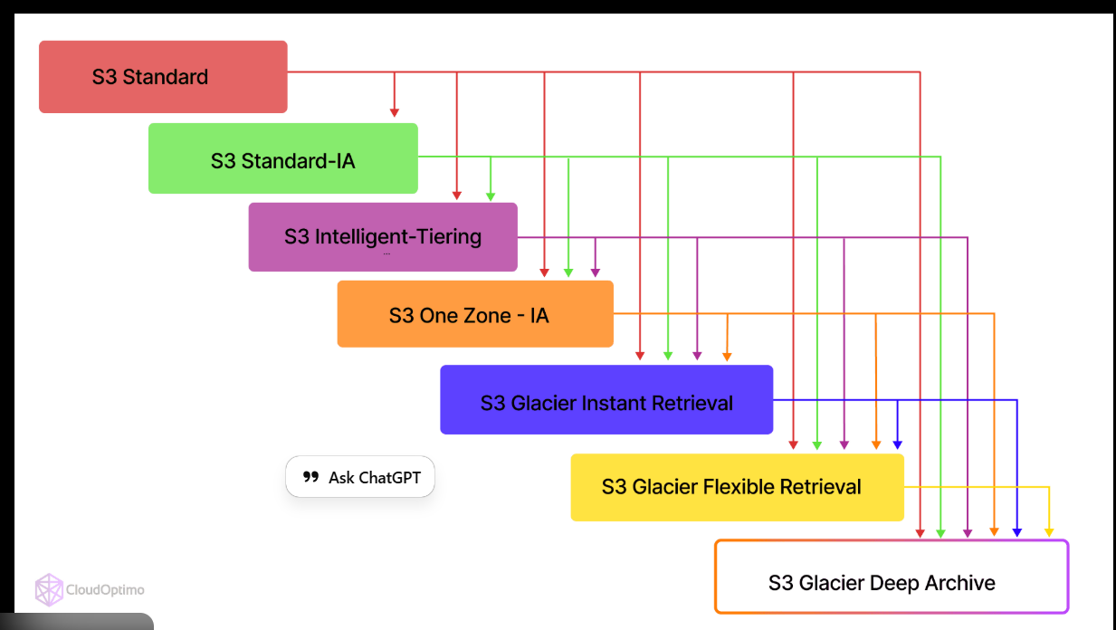
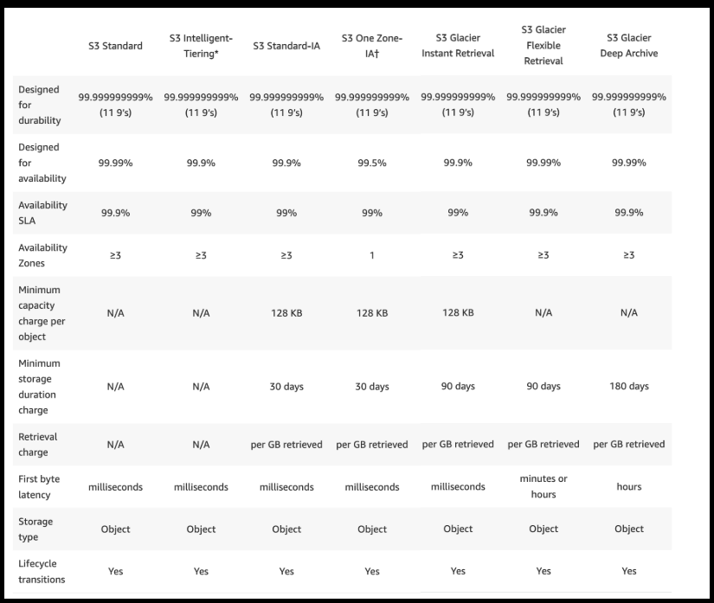
- S3 object was initially stored in S3 Standard
- S3 Standard is meant for frequently accessed data
- The object was rarely accessed
- Storage class was changed to a cheaper option
- This reduced S3 storage costs
- Data is still available when needed
- Helps in AWS cost optimization
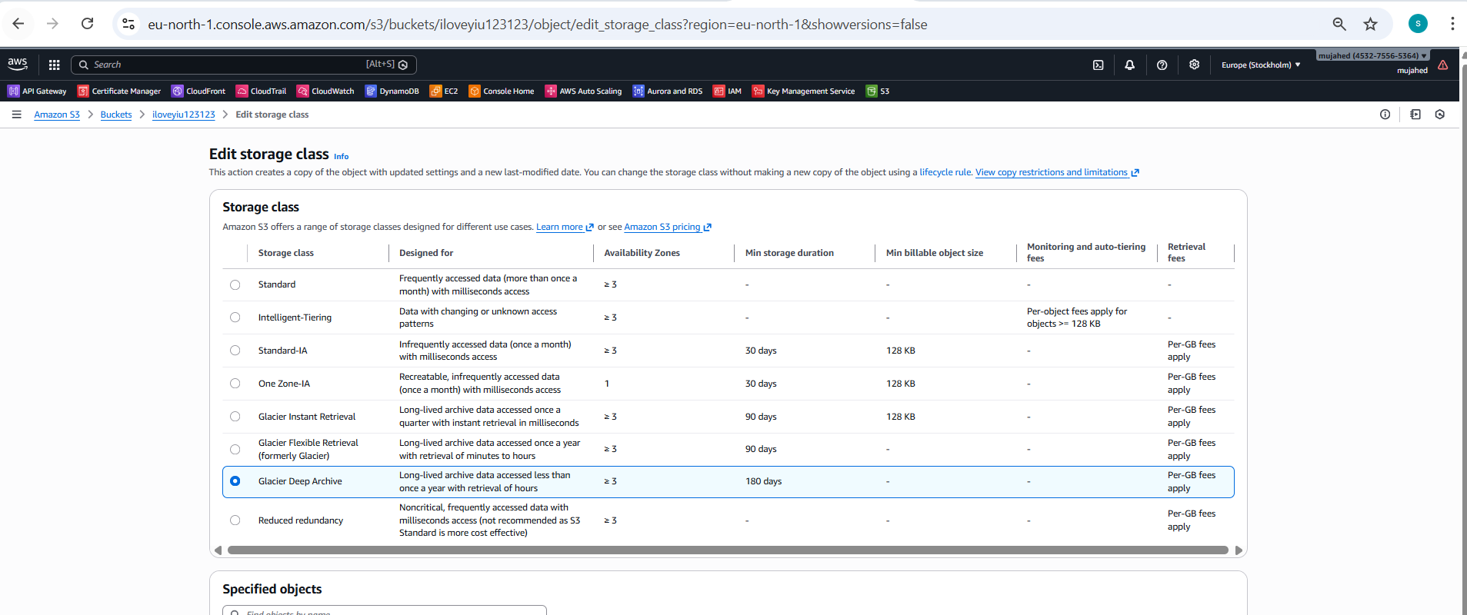
- S3 Cost Optimization – Moving Data to Glacier Deep Archiv
- The file was rarely accessed
- It was originally stored in S3 Standard
- S3 Standard is meant for frequently used data
- Keeping unused data in S3 Standard increased cost
- The file was moved to S3 Glacier Deep Archive
- Glacier Deep Archive is much cheaper
- It is used for long-term, rarely accessed data
- The data remained safe with no data loss
- Storage cost was greatly reduced
- Retrieval takes more time, but this is acceptable for archived data
- This change lowered the monthly S3 bill

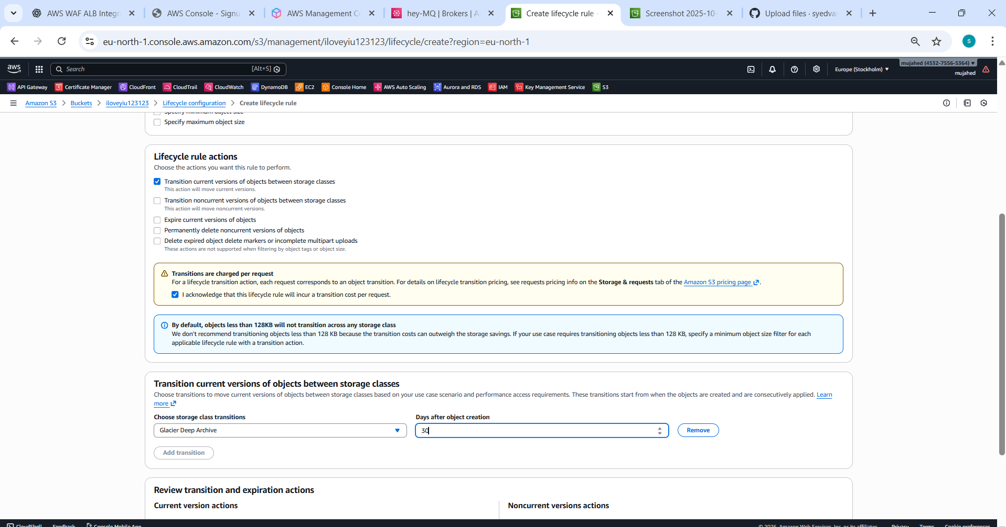
- Enable Lifecycle Policies – S3 Cost Optimization
- Data stored in Amazon S3 increases over time
- Older files are accessed less frequently
- Keeping old data in S3 Standard increases storage cost
- A Lifecycle Policy was enabled to optimize cost
- Lifecycle policy automatically manages storage classes
- No manual effort is required after setup
- Objects in S3 Standard are moved to Glacier after 30 days
- Data remains safe with no loss
- Storage costs are reduced by using cheaper storage
- This action lowers the monthly S3 bill

- Load balancer cost optimization
- Use Application Load Balancer only when required
- Delete unused target groups
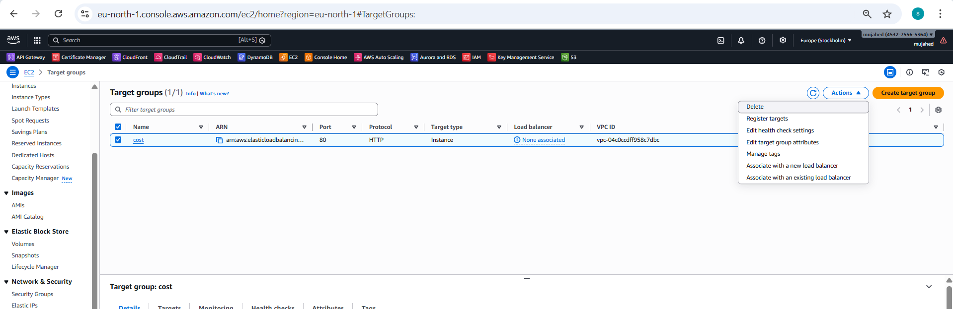
- Deleting Unused Target Groups – Simple Explanation
- Target groups are created for load balancers, testing, or old applications
- Over time, some target groups become unused
- Unused target groups are not attached to any load balancer
- They do not receive traffic
- Keeping unused target groups adds unnecessary management overhead
- Identifying and deleting them cleans the AWS environment
- Helps avoid configuration confusion
- Improves overall resource management
- What Happens After Deleting Target Groups
- The unused target group is permanently removed
- No impact on running applications
- AWS environment becomes clean and organized
- Easier load balancer configuration
- Better infrastructure management
- AWS Cost Optimization – Best Practices
- Regularly delete unused AWS resources
- Right-size EC2 and RDS instances based on usage
- Use Auto Scaling to match demand
- Apply S3 Lifecycle Rules for old data
- Monitor AWS usage and billing daily
- Set AWS Budgets to track and control spending
- Conclusion
- AWS cost optimization reduces cloud expenses
- No impact on performance or availability
- Achieved by:

